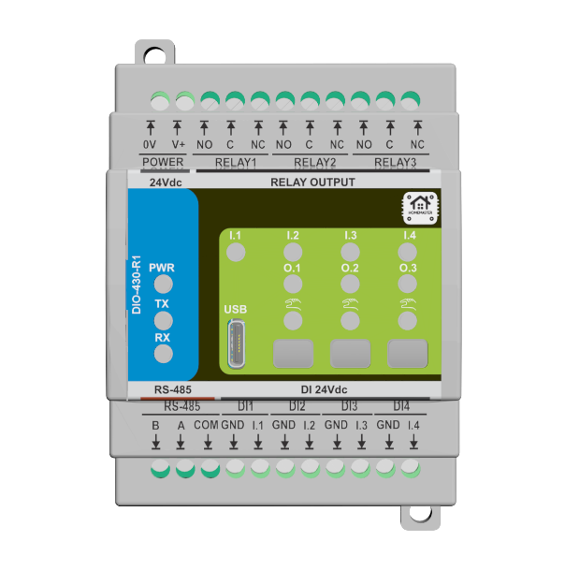

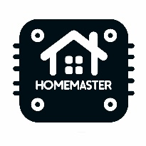

**Datasheet**

**DIO-430-R1 Module**

**Part No. 0000004**

**About the product**

**DIO-430-R1 is an advanced home automation solution built on the RP2350A, offering seamless integration with Home Assistant via MiniPLC/MicroPLC.  
With a variety of onboard hardware resources, it enables automation tasks such as pump and fan control, temperature regulation and monitoring, lighting control, and creation of lighting scenes.  
DIO-430-R1 functionality can be expanded with additional extension modules through a wired RS-485 Modbus system.  
Furthermore, it supports programming via the Arduino IDE using the USB interface, providing developers with extensive flexibility and customization options.**

**Electrical Data**

|  |  |
| --- | --- |
| Power supply | 24VDC, 120VDC - 370VDC,  USB-C female (5V DC via USB-C) for programming |
| Power consumption | typ. 1.85W, max. 3W |
| Raspberry PI | RP2350A |
| Digital Inputs | 4 isolated, surge protected digital sourcing inputs  logic 0: 0 ... 9.2VDC  undefined: 9.2 ... 15.8VDC  logic 1: 15.8 ... 24VDC |
| Outputs | 3 digital output (relay with optocoupler and varistor surge protection), dry contact  250VAC 16A at cosᵠ =1,  250VAC 9A at cosᵠ =0.4  30VDC 10A |
| RS-485 | Half-duplex,  data rate 115,2 kbps,  short-circuit current limited and protected against excessive power dissipation,  fail-safe for open circuit,  surge protected |
| USB | USB type-C USB Specification 2.0 compliant,  ESD protected,  Silicon Labs CP2102N USB-to-UART bridge controller,  Virtual COM Port Device Drivers, Works with existing COM port Applications, Supported on Windows, Mac, and Linux |
| Real-time clock | PCF8563 |
| Buzzer | 85dB Passive (external drive) Electromagnetic Type 2.7kHz |
| Ambient temperature | 0 ... 40°C / 32 ... 104°F |
| Humidity | max. 95% r.H. (non condensing) |

**Information: \***

High loads at the digital outputs result in heat development, which can influence the lifetime in the long run. We recommend using coupling relays with loads greater than 5A.

**Connections**

|  |  |
| --- | --- |
| Terminals | 300V 20A 26-12 AWG 2.5mm2,  Torque of terminal blocks 0.5 ... 0.6Nm /0.37 ... 0.44 lbf ft,  Pitch: 5.08mm(.200") |
| USB | USB type-C |

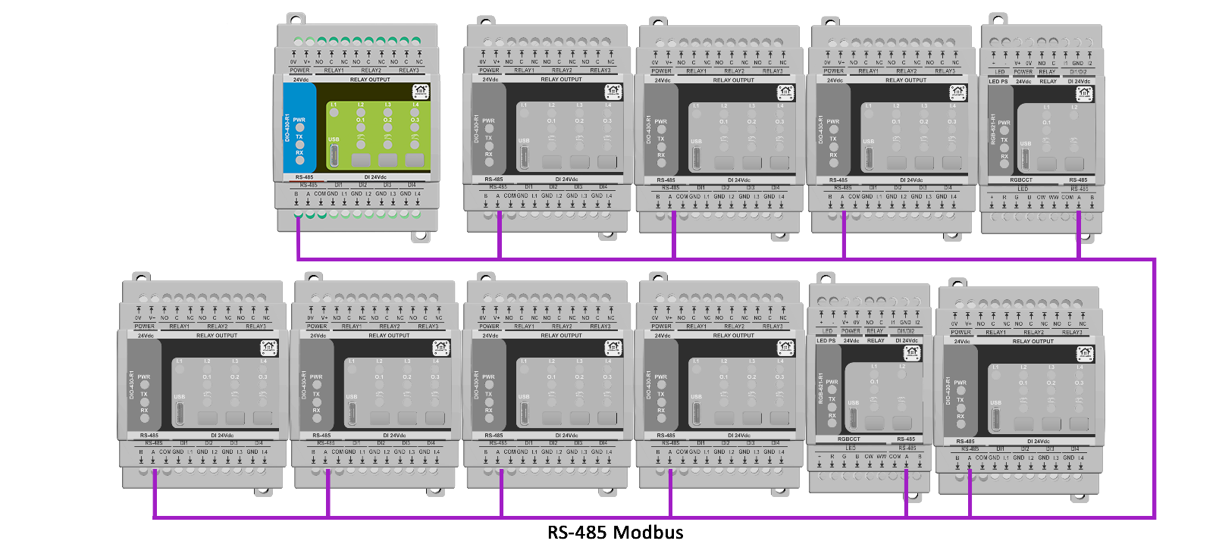

**Product Characteristics**

|  |  |
| --- | --- |
| Mounting type | DIN rail according to EN50022, 35mm |
| Colors | Light Gray/Black, Smoke Panel |
| Material | PC/ABS/V0 |
| Finish | Matte |

**Weight & Dimensions**

|  |  |
| --- | --- |
| Net weight | 000g |
| Total weight | 000g |
| Product dimensions | 52.5 x 90 x 59 mm (2.07 x 3.54 x 2.32 in) (LxWxH),  1 division units |
| Pack size | 000x0x0mm (0 x 0 x 0 in) (LxWxH), |

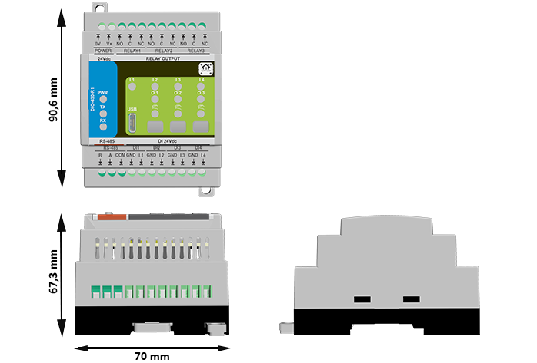

**Certifications & Standards**

|  |  |
| --- | --- |
| Safety rating | IP20 |
| Operation | Type 1 (UL60730-1, CSA E60730-1) |
| Rated impulse voltage for digital output | 2.5kV (UL60730-1, max. Altitude 2000m) |
| Degree of pollution | 2 |
| Certifications | CE, UL60730-1, CSA E60730-1 |

The DIO-430-R1 enables a variety of connected devices to work with HOMEMASTER technology.

See https://www.home-master.eu for more details.

Communication between iPhone, iPad, Apple Watch, HomePod, or Mac and the HomeKit- enabled

DIO-430-R1 is secured by ESPHome and Home Assistant technology.

Installation must be carried out by a qualified electrician in accordance with the relevant regulations.

**Published by**

**ISYSTEMS AUTOMATION S.R.L.**

Diligentei, Nr. 18,

Ploiesti,

Prahova,

Romania

Tel: +40721389963

https://www.home-master.eu